Exercise-1 : Singleton Pattern Example
231fa0f80@gmail.com
Logger.java:
package Singleton;
public class Logger {
private static Logger instance;
private Logger() {
System.out.println("Logger instance created.");
}
public static Logger getInstance() {
if (instance == null) {
instance = new Logger();
}
return instance;
}
public void log(String message) {
System.out.println("LOG: " + message);
}
}
Main.java :
package Singleton;
public class Main {
public static void main(String[] args) {
Logger logger1 = Logger.getInstance();
Logger logger2 = Logger.getInstance();
logger1.log("Application started.");
logger2.log("User logged in.");
System.out.println(logger1 == logger2);
}
}
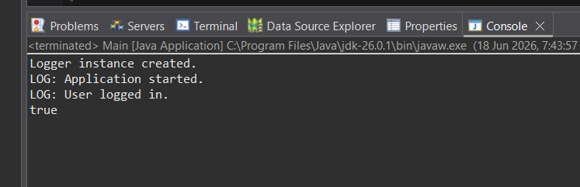

Exercise 2: Implementing the Factory Method Pattern
Document Interface :
package com.factory;
public interface Document {
void open();
}
Concrete Document Classes :
WordDocument.java :
package com.factory;
public class WordDocument implements Document {
@Override
public void open() {
System.out.println("Opening Word document.");
}
}
PdfDocument.java :
package com.factory;
public class PdfDocument implements Document {
@Override
public void open() {
System.out.println("Opening PDF document.");
}
}
ExcelDocument.java :
package com.factory;
public class ExcelDocument implements Document {
@Override
public void open() {
System.out.println("Opening Excel document.");
}
}
Abstract Factory Class :
DocumentFactory.java :
package com.factory;
public abstract class DocumentFactory {
public abstract Document createDocument();
}
Concrete Factory Classes :
WordDocumentFactory.java :
package com.factory;
public class WordDocumentFactory extends DocumentFactory {
@Override
public Document createDocument() {
return new WordDocument();
}
}
PdfDocumentFactory.java :
package com.factory;
public class PdfDocumentFactory extends DocumentFactory {
@Override
public Document createDocument() {
return new PdfDocument();
}
}
ExcelDocumentFactory.java :
package com.factory;
public class ExcelDocumentFactory extends DocumentFactory {
@Override
public Document createDocument() {
return new ExcelDocument();
}
}
Test the Factory Method Implementation:
FactoryTest.java:
package com.factory;
public class FactoryTest {
public static void main(String[] args) {
DocumentFactory wordFactory = new WordDocumentFactory();
Document word = wordFactory.createDocument();
word.open();
DocumentFactory pdfFactory = new PdfDocumentFactory();
Document pdf = pdfFactory.createDocument();
pdf.open();
DocumentFactory excelFactory = new ExcelDocumentFactory();
Document excel = excelFactory.createDocument();
excel.open();
}
}

